SIM800H Embedded AT Compiling Environment _V1.0

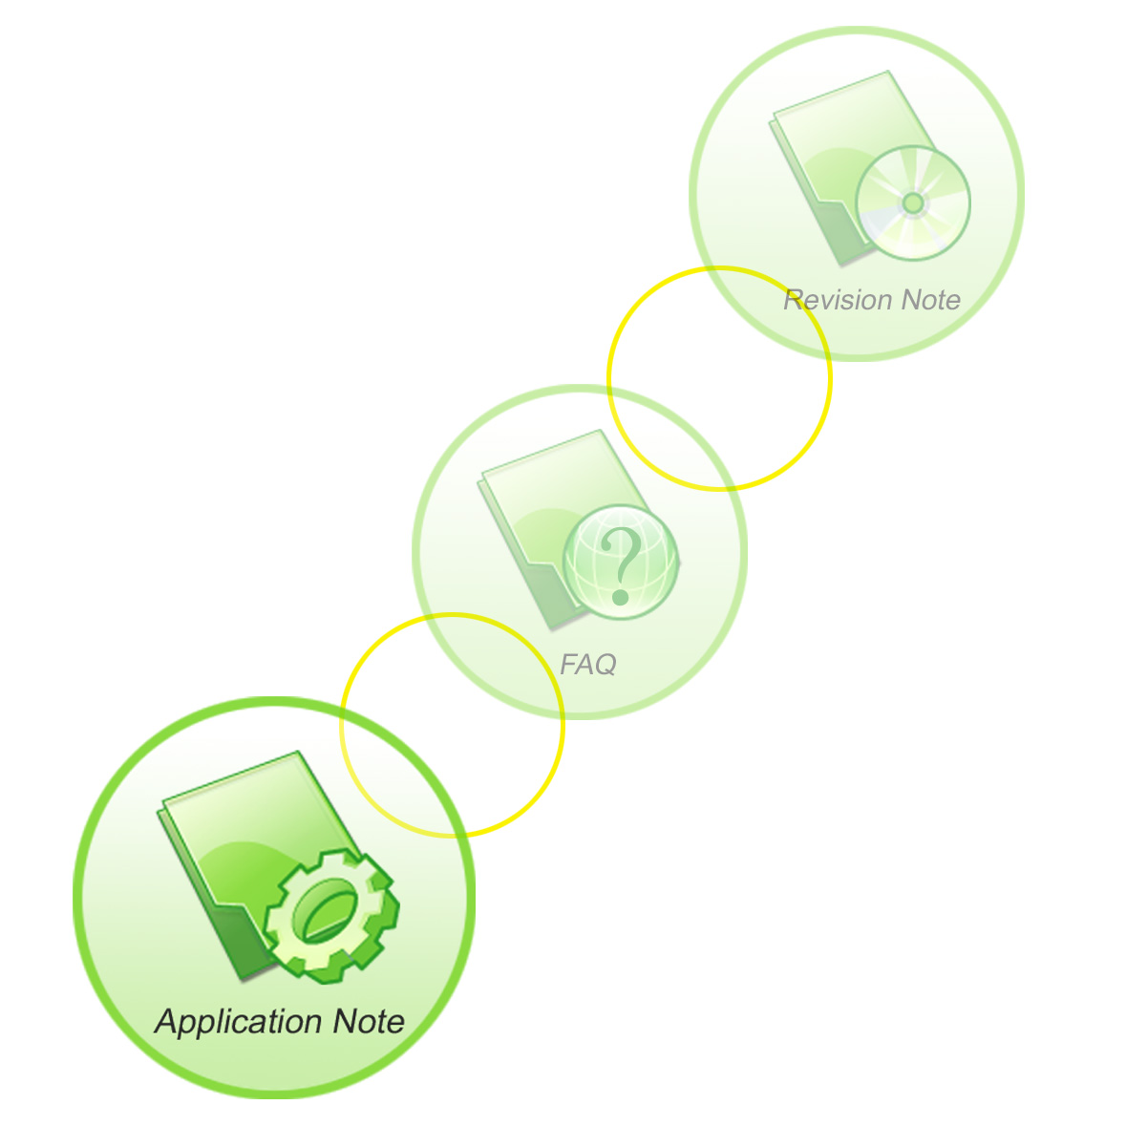

Document name: | SIM800H Eembedded AT Compiling Environment
Version: | 1.0
Date | 2013-07-11
Status | Release
Doc Control ID: | SIM800H Eembedded AT Compiling Environment_V1.0

General Notes
Simcom offers this information as a service to its customers, to support application and engineering efforts that use the products designed by Simcom. The information provided is based upon requirements specifically provided to Simcom by the customers. Simcom has not undertaken any independent search for additional relevant information, including any information that may be in the customer’s possession. Furthermore, system validation of this product designed by Simcom within a larger electronic system remains the responsibility of the customer or the customer’s system integrator. All specifications supplied herein are subject to change.

Copyright
This document contains proprietary technical information which is the property of SIMCOM Limited., copying of this document and giving it to others and the using or communication of the contents thereof, are forbidden without express authority. Offenders are liable to the payment of damages. All rights reserved in the event of grant of a patent or the registration of a utility model or design. All specification supplied herein are subject to change without notice at any time.

Copyright © Shanghai SIMCom Wireless Solutions Ltd. 2013

Content
Version History 4
1 Tool and Code architecture 5
2 Compiling 6
2.1 Compiler environment 6
2.2 Compiling process introduction 6
2.3 Client Configuration 7
2.4 Add new file to project 7
3 Download 9
4 Debug 9
4.1 EAT_UART_DEBUG_MODE_UART mode 9
4.2 Catcher tool operation 10
Contact us: 15

Version History

Date | Version | modification | Owener
2013-7-11 | 1.00 | Original | Bin Mao

Tool and Code architecture
Compiler: RVCT
Version:ARM/Thumb C/C++ Compiler, RVCT3.1 [Build 569]
Compiling tool:winmake (under ..\build\)
Download tool:SIMCom_SIM800H_EAT_flash_Tool_V1.01

Folder list:

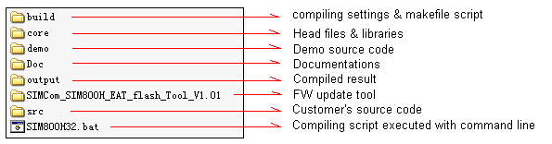

Compiling

Compiler environment
Once RVCT compiler installed successfully, armcc command will show you correct version info as following.
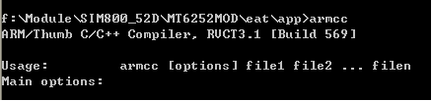

SIM800H E-AT project will be compiled with script line.

Compiling process introduction

Build list description.

File | function | User-configuration
user.mak | Configuration file for compiling path,source code folder,and compiling case,etc. | Yes
Makefile | System entrance | No
option.mak | Configure compiling environment | No
app_build.mak | Compile source code | No

Compiling process is as following.
SIM800H32.bat
build/Makefile
build/option.mak
build/user.mak
Create necessary folder, copy scatter file to output folder
Go to SRC_OPEN_MODE_NAME folder to compile case
link *.a and main.o
files,generate bin file

Figure 1 compiling process

Bin file is available in folder defined by OUTPUT_BIN_DIR（user.mak file defined）.
App file will be generated to path core/SIM800H32_MXIC_EMBEDDEDAT\.
Downloading core and app file need 1308B01SIM800H32_EAT.cfg file. If just update app file, just check app option.

Client Configuration
Client could modify some settings for user.mak.

#RVCT 3.1 Root Directory
DIR_ARM = C:\Progra~1\ARM\RVCT
#source file folder
SRC_DIR = demo
#current case to be compiled
SRC_OPEN_MODE_NAME = adc

Add new file to project
Here, we add a new test case, for example sms case, source cdoe includes main.c, app_sms.c and app_sms.h.
Note, case source should include main.c file for app entrance.

Steps for this case.
1) Create sms folder;
2) Generate main.c, app_sms.c and app_sms.h files.
3) Copy Makefile from demo/adc to root sms folder.
Two options here to orgnizate source files.

- compile all *.c files (ensure main.c included)
#First mothod#
S1:= $(wildcard *.c)
SOURCE :=$( S1)

- specify source file to compile
#Second mothod#
SOURCE := main.c \
app_sms.c

*Note, we recommend main.c file for app entrance in E-AT project. If there has no mail.c but different source file only, should modify following info to link to main.o file.
MAIN_SRC := app_demo_uart.c
MAIN_OBJ := main.o

4) modify user.mak file.
# root directory
SRC_DIR = src
# case folder to be compiled
SRC_OPEN_MODE_NAME = sms

5) call sim800H32.bat all to compile or sim800H32.bat clean to clean generated files.

Download
Objective file includes two sections. One is core file for simcom module; another is app file for E-ATcase.
Normally, core is here, just update app file. But if need new core version to build project, should download these two sections together. Make sure app file is compiled based on this new core file.

Debug
Three methods are available to view logs.
- eat_uart_write() interface to print log info
- configure DEBUG port as EAT_UART_DEBUG_MODE_UART mode, and eat_trace() interface print log info which could be visible with hyperterminal
- Configure DEBUG port as EAT_UART_DEBUG_MODE_TRACE mode, and eat_trace() interface prints log info which only be visible with Catcher tool provided by SIMCom.

EAT_UART_DEBUG_MODE_UART mode
app_func_ext1 ():
EatUartConfig_st cfg =
{
EAT_UART_BAUD_115200,
EAT_UART_DATA_BITS_8,
EAT_UART_STOP_BITS_1,
EAT_UART_PARITY_NONE
};
// configue EAT_UART_2 as debug
eat_uart_set_debug(EAT_UART_2);

// coinfigure DEBUG port as UART mode.
eat_uart_set_debug_config(EAT_UART_DEBUG_MODE_UART, &cfg);

Catcher tool operation

- Conigure UART2 output log info.

void app_func_ext1(void*data)
{
eat_uart_set_debug(EAT_UART_2);
……
}

- Connect UART2 to PC, and launch on Catcher tool.

- Pick up data base file.

Database file is provided by SIMCom, such as BPLGUInfoCustomAppSrcP_xxx _xxx_EMBEDDEDAT.
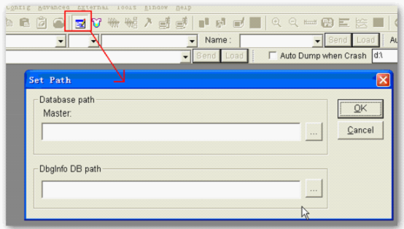

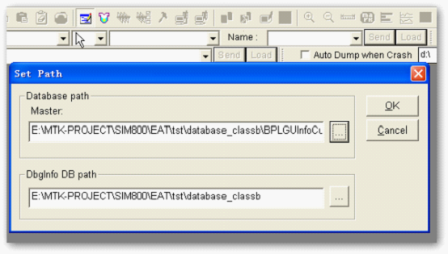
- Configure port

Pick up correct COM port, choose suitable baud rate. Usually baud rate for standard RS232 cable is 115200 bps maximum.

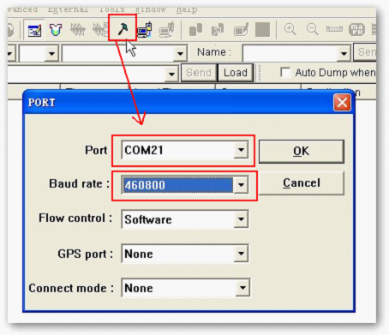

- Hit “Connect” button to continue.
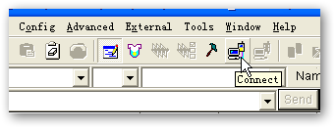
- Configure filter.

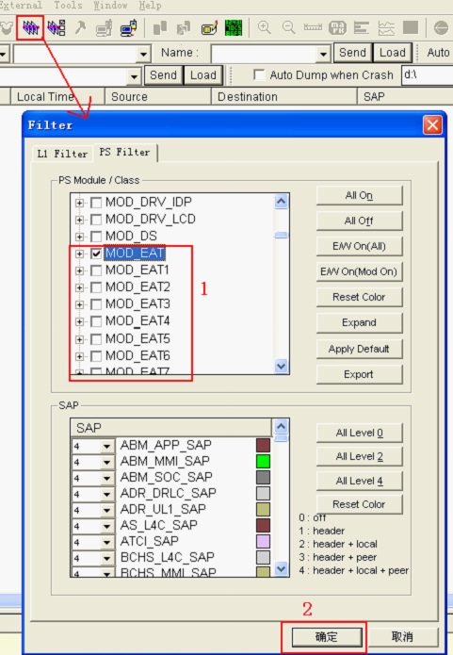

- Ready to catch log info. Hit “View-> PS Integrated”, log trace will be visible.

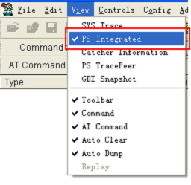
- Disconnect communication to save log.
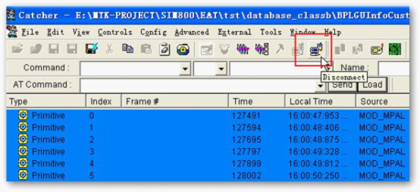
- Hit “File->Save log as…” option to save log.
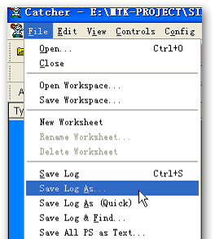

- Log trace is like following.

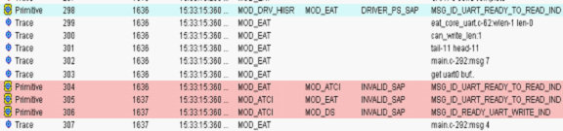

Contact us

Shanghai SIMCom Wireless Solutions Ltd.
Add: Building A, SIM Technology Building, No.633 Jinzhong Road, Changning District, Shanghai, P. R. China 200335
Tel: +86 21 3252 3300
Fax: +86 21 3252 3301
URL: www.sim.com/wm

